**ASAS Plug-In for VStar**

*Description:* This plugin allows you to open text files in the format of the [All Sky Automated Survey (ASAS)](http://www.astrouw.edu.pl/asas/?page=main).

Data files can be downloaded from the ASAS website or by using the AAVSO's VSX.

For the ASAS website, click on the above link. This will give you the All Sky Automated Survey main page. On the left side of the main page click on “Catalogs” (under Services). The Catalogs page discusses measurements through both I-band and V-band filters. However, I-band filter data does not seem to be accessible, so only Johnson V-band photometry is utilized in the VStar ASAS plug-in. Select “The ASAS-3 Photometric V-Band Catalog” under ASAS-3 Results. This yields the ASAS All Star Catalog. ASAS uses a designation for each object that incorporates RA and DEC, for example 035812+1629.7. The plugin creates observations with a name of the format “ASAS “ + this designation. And you will find star names in VSX and other databases with this name. As an example, use the RA/DEC coordinates 035812+1629.7 in the Source field and click “Search”. This will give:

#### **ASAS (asas3) Catalog Query Results (15")**

# ID mag err Nobs  
**#[035812+1629.7](http://www.astrouw.edu.pl/cgi-asas/asas_variable/035812+1629.7,asas3,0,0,500,0,0)**

**[035812+1629.7](http://www.astrouw.edu.pl/cgi-asas/asas_variable/035812+1629.7,asas3,0,0,500,0,0) 9.516 0.034 224**[**035812+1629.7**](http://www.astrouw.edu.pl/cgi-asas/asas_variable/035812+1629.7,asas3,0,0,500,0,0) **9.529 0.036 36**[**035812+1629.7**](http://www.astrouw.edu.pl/cgi-asas/asas_variable/035812+1629.7,asas3,0,0,500,0,0) **9.528 0.075 183**[**035812+1629.7**](http://www.astrouw.edu.pl/cgi-asas/asas_variable/035812+1629.7,asas3,0,0,500,0,0) **9.500 0.042 34**

Alternately, the star name may be entered such as R Car. This yields:

#### **ASAS (asas3) Catalog Query Results (15")**

# ID mag err Nobs  
**#[R Car (093215-6247.3)](http://www.astrouw.edu.pl/cgi-asas/asas_variable/093215-6247.3,asas3,0,0,500,0,0)**

**[093215-6247.3](http://www.astrouw.edu.pl/cgi-asas/asas_variable/093215-6247.3,asas3,0,0,500,0,0) 7.392 1.357 565**[**093217-6247.5**](http://www.astrouw.edu.pl/cgi-asas/asas_variable/093217-6247.5,asas3,0,0,500,0,0) **6.641 0.631 12**[**093213-6247.1**](http://www.astrouw.edu.pl/cgi-asas/asas_variable/093213-6247.1,asas3,0,0,500,0,0) **6.126 0.000 1**[**093215-6247.3**](http://www.astrouw.edu.pl/cgi-asas/asas_variable/093215-6247.3,asas3,0,0,500,0,0) **7.575 0.191 22**[**093215-6247.3**](http://www.astrouw.edu.pl/cgi-asas/asas_variable/093215-6247.3,asas3,0,0,500,0,0) **7.602 1.274 567**[**093217-6247.4**](http://www.astrouw.edu.pl/cgi-asas/asas_variable/093217-6247.4,asas3,0,0,500,0,0) **5.121 0.128 17**[**093213-6247.2**](http://www.astrouw.edu.pl/cgi-asas/asas_variable/093213-6247.2,asas3,0,0,500,0,0) **6.068 0.000 1**

Click on one of the entries. This yields

**ASAS 093215-6247.3 Light Curve (asas3).**

Click on “GetData”. The data file will look like:

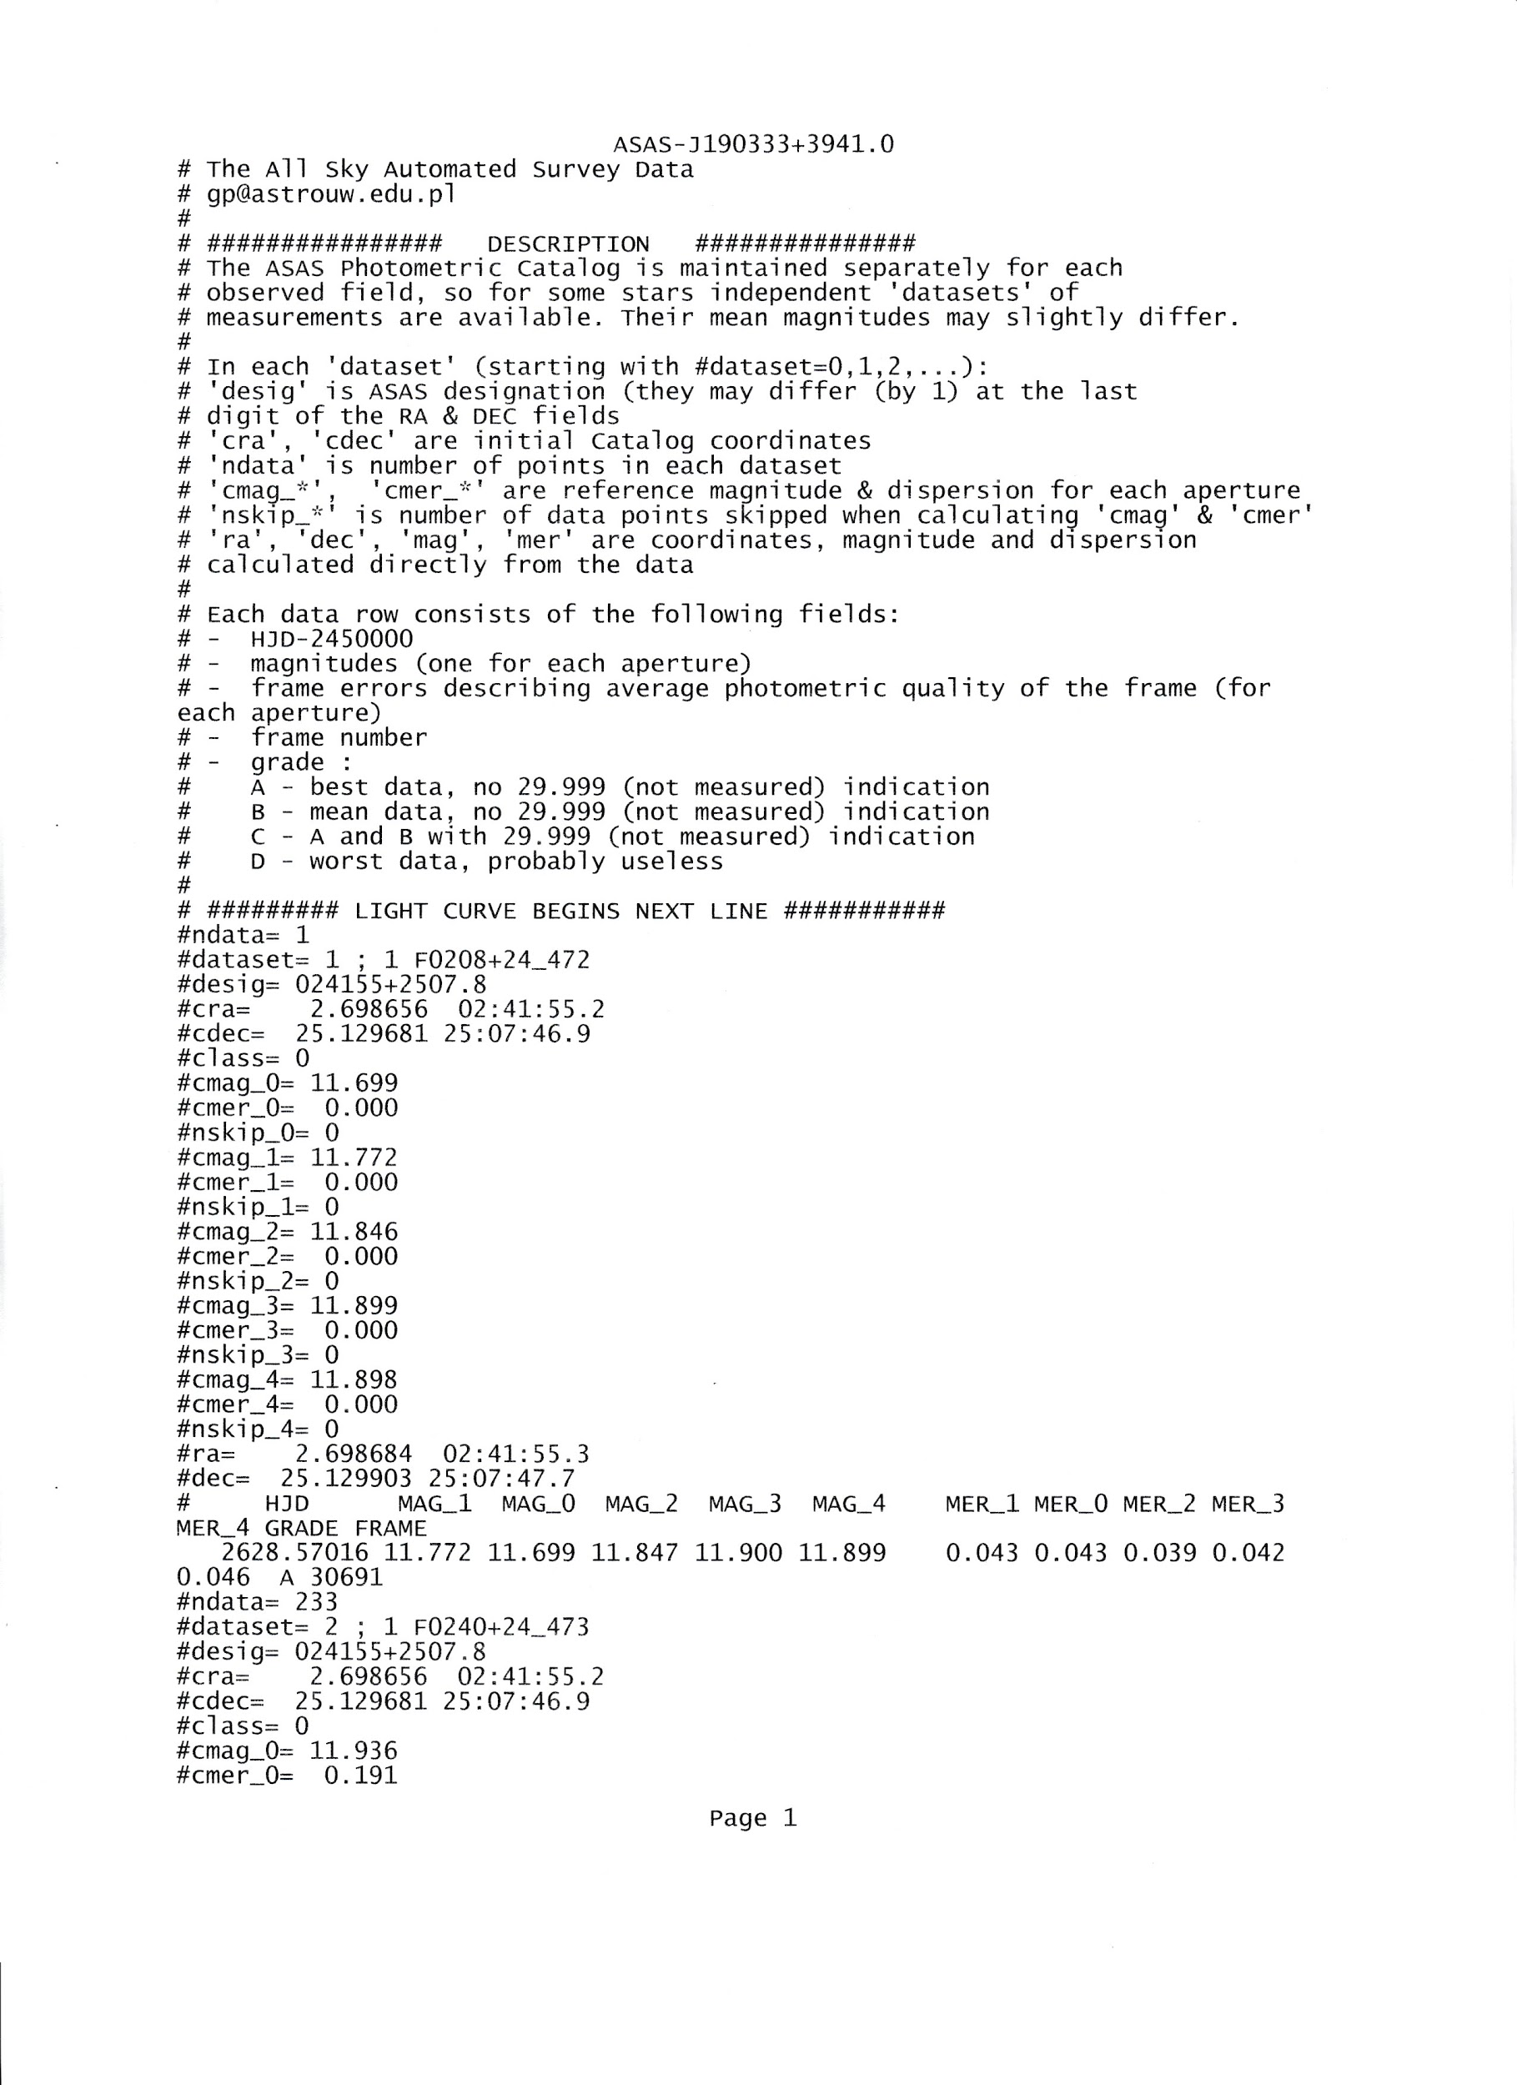

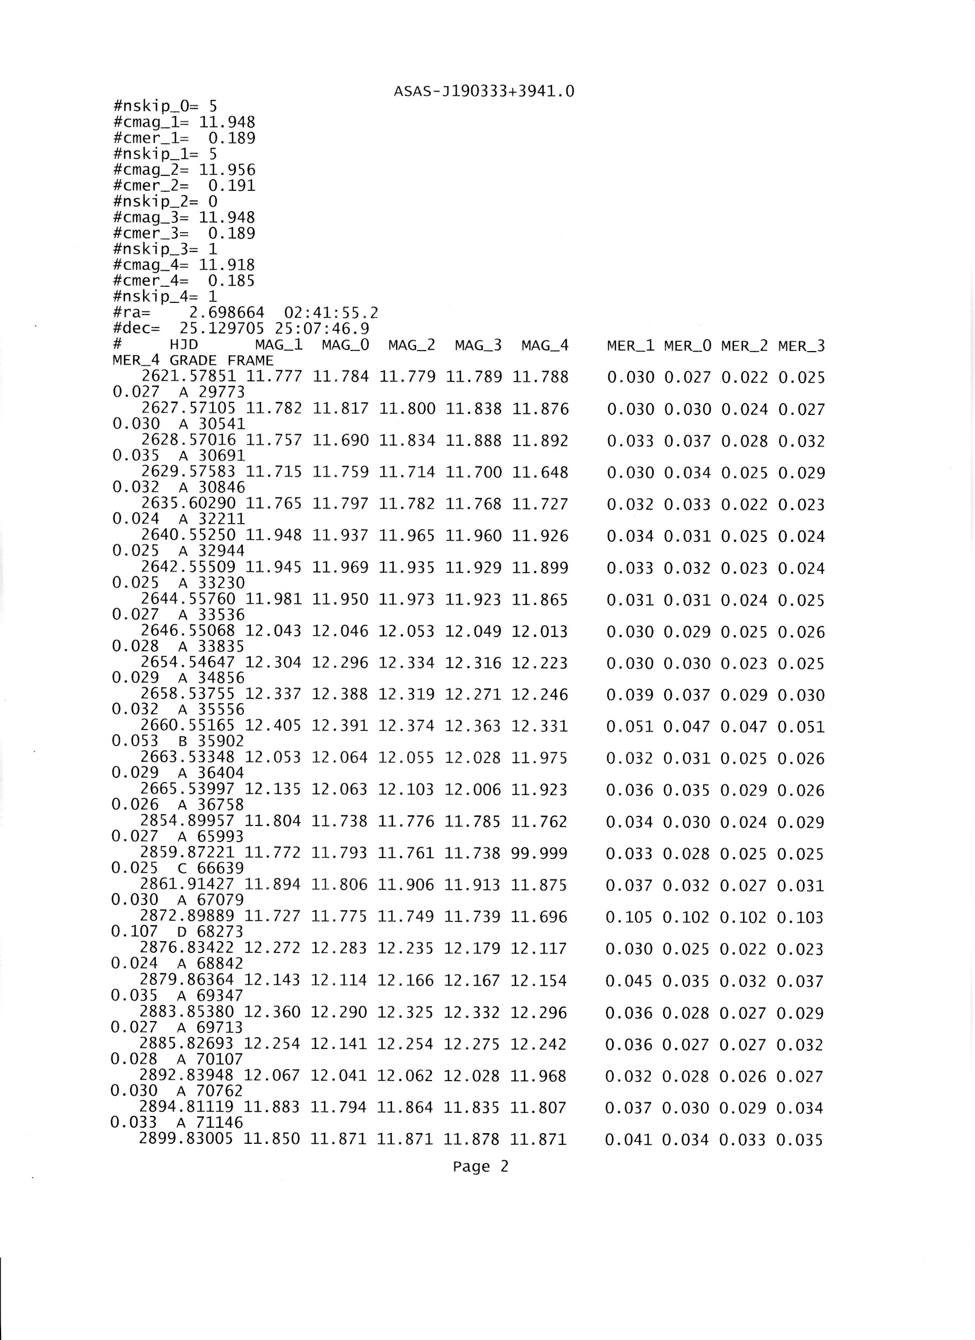

Note that each line in the ASAS file has multiple measurements and a grade. The plugin ignores any observation with a grade of C or worse. The multiple measurements per line represent different sized photometric apertures from smallest to largest. Given that ASAS has a plate scale over 10 arcsec per pixel, the plugin always picks the smallest (first) measurement. Copy and paste the data into a .txt file and save. From VStar, select the dropdown *File* menu and select “New Star from ASAS file”. This will give you the VStar light curve plot. A variety of analyses are available from this point. For R Car, the VStar light curve plot is:

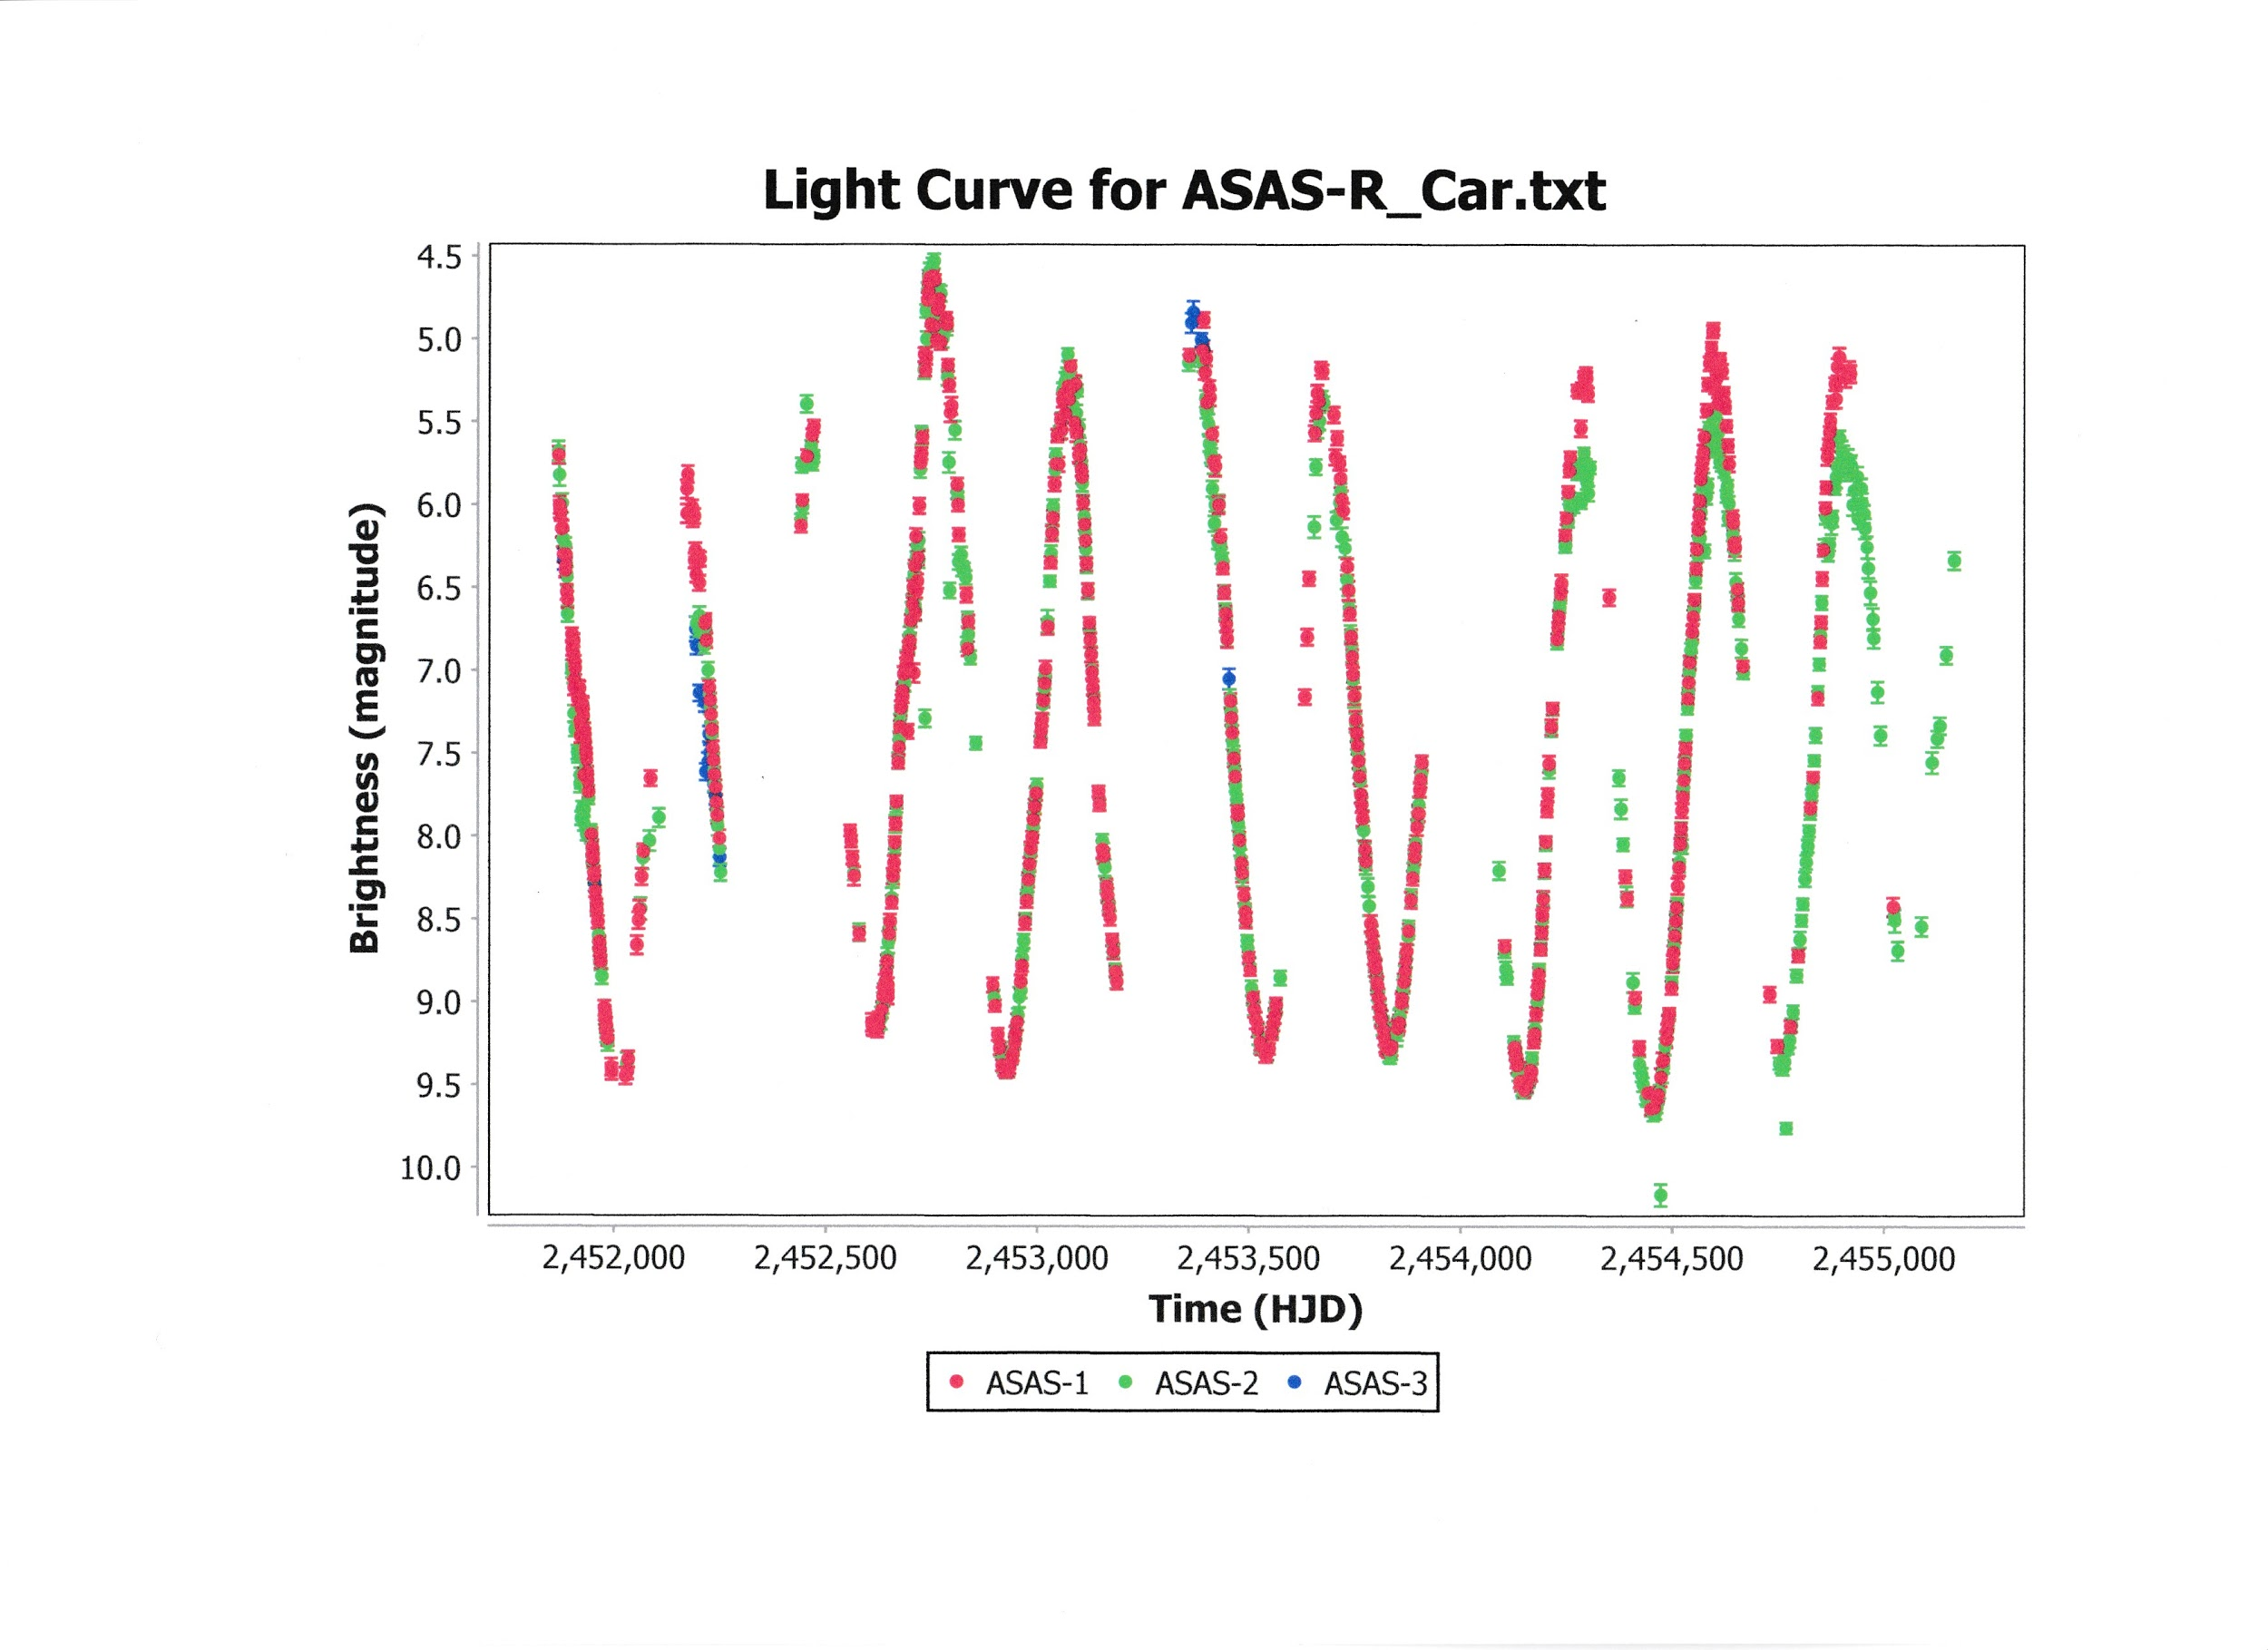

For VSX, chose the Search option, enter the name of the star (R Car in this example), and click Search. This yields the VSX Detail page for R Car. Go to External Links/Location/Select and select ASAS Light Curve from the various options available. Click Go. The resulting page will be the same as for direct access through the ASAS website. Click on “GetData” as above and follow the same procedure by saving the data in a .txt file and executing VStar as above. In either case the light curve is as shown above.

|  |  |  |  |  |  |  |  |
| --- | --- | --- | --- | --- | --- | --- | --- |
|  |  |  |  |  |  |  |  |